Kenovo Electric Blender
High Level Design

Version 1.0

Date: March 26, 2016
Revision History
Date | Version | Author | Comment
26/3/2016 | 1.0 | Bassam Hani | Initial Version

Table of Contents

Kenovo Electric Blender 1
1 Introduction 4
1.1 Scope 4
1.2 Purpose 4
1.3 System Overview 4
1.4 Supporting Documentation 4
2 Requirements 5
2.1 Customer Requirements 5
2.2 Software Requirements 5
3 Design 6
3.1 System Components 6
3.1.1 MCAL layer 6
3.1.2 Basic Software layer 7
3.1.3 Application layer 7

Introduction

Scope
This document identifies components and design patterns to be used in creating the Kenovo Electric Blender system. The high-level design is based on the system requirements, as well as customer requirements.

Purpose
This document lay out the technical basis for the system to be created and maintained. It is intended as an introduction for customers, technical stakeholders and software developers that will be involved in the project.

System Overview
The system will be delivered as:
- DC motor which will be responsible for driving the speeds of the blender.
- Tactile switch to change the speeds of the motor.
- Push button to activate or deactivate the tactile switch and control the state of the system.
- Microcontroller which will be responsible for controlling the system.

Supporting Documentation
The following documents were used as input to this design:
- Software Requirement Specification
- Customer Requirement Specification
- SIQ

Requirements

Customer Requirements
Requirement ID | Description | Rate | Notes
REQ_01 | Electric Blender should have three speeds | M | N/A
REQ_02 | User should change the speed using button | M | N/A
REQ_03 | Speed sequence is Off-> Speed1 -> Speed2 ->Speed3 to Off | M | N/A
REQ_04 | Second Button for on and off | HD | Refer to CR_01
REQ_05 | Electric Blender should be stable | HD | N/A

Software Requirements
Requirement ID | Description | Rate | Notes
SRS_01 | Developing DIO Driver for Atmega32 microcontroller | M | N/A
SRS_02 | Developing PWM Driver for Atmega32 microcontroller | M | N/A
SRS_03 | Developing Tactile-switch Driver | M | N/A
SRS_04 | Developing DC-motor Driver | M | N/A
SRS_05 | Developing stable application to control motor with 3 different speeds using the tactile switch and to make sure the DC motor is stable on its speed. | M | N/A

Design

System Components
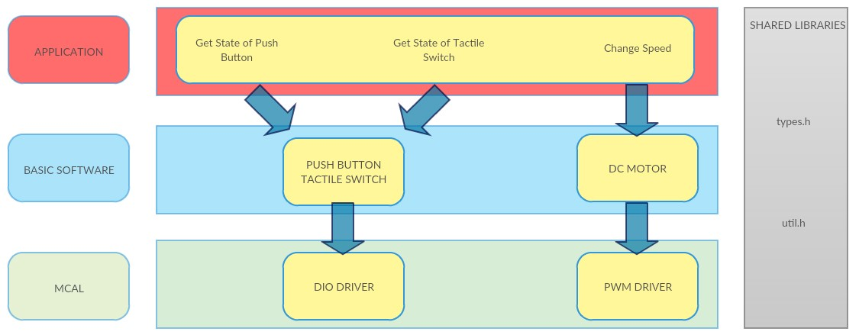

MCAL layer
It is the layer that contains all the components inside the microcontroller that will be used in the Blender system by the components of the basic software layer, MCAL layer components are:
- DIO (Digital Input Output)
Which will be used to take the inputs from the tactile switch and push button in order for the microcontroller to take decision based on the input of the user
API | Details
u8 DIO_u8ReadPinVal (u8 Copy_u8PinIdx, u8* Copy_u8PtrToVal) | This API is used by the Push Button and Tactile Switch to get the state of the pin connected to the switch if it is high or low.

- PWM (Pulse Width Modulation)
The pulse width modulation component will be used to drive the DC MOTOR with the desired speeds based on the inputs to the microcontroller
API | Details
Void PWM_Set_Duty_Cycle (u8 copy_u8Duty) | This API is used to set the Duty Cycle of the PWM signal to control the speed of the motor.

Basic Software layer
This layer will contain the hardware components that will be used by the Application layer and which will also use the MCAL layer components, components of this layer are:
- DC MOTOR
API | Details
void DCMotor_voidOn (void) | This API is used to switch on the DC Motor.
void DCMotor_voidOff (void) | This API is used to stop the DC motor.
void DCMotor_voidChangeSpeed (u8 copy_u8Speed) | This API is used to change the speed of the DC motor using the PWM component in the MCAL layer.

- TACTILE SWITCH
API | Details
u8 TACTILE_u8GetButtonState (u8 Copy_u8ButtonIdx, u8 *Copy_u8ButtonVal); | This API is used by the application to get the state of the Tactile Switch whether it is pressed or not

- PUSH BUTTON
API | Details
u8 Tactile_u8GetButtonState (u8 Copy_u8ButtonIdx, u8 *Copy_u8ButtonVal); | This API is used by the application to get the state of the Push Button whether it is pressed or not

Application layer
Application layer will be responsible for operating the system by giving commands to the components of the basic software layer which are going to operate based on the use of the MCAL layer
the following APIs will be used in this layer to operate the system
API | Details
TACTILE_u8GetButtonState() | To get the state of the tactile switch and push button.
DCMotor_voidChangeSpeed() | To change the speed of the motor.
DCMotor_voidOff() | To turn the motor off.

